Daigram-01
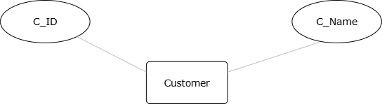
.

.
Diagram-02
LIBRARY MANAGEMENT SYSTEM





